Name – Samarth Udagi

MIS – 112315160

Python Lab 2

********************************

1. Write a Program for checking whether the given number is an even number or not.

Code :   
a=int(input("Enter a number : "))

if a%2 :

    print("Given number is odd")

else :  print("Given number is even")

Output :   


Q.2 Using for loop, write a program that prints out the decimal equivalents of 1/2, 1/3, 1/4, . . . , 1/10.

Code :

for i in range(2,11) :

    print("1/"+str(i)+ " = ",end=" ")

    print(1/i)

Output :   
 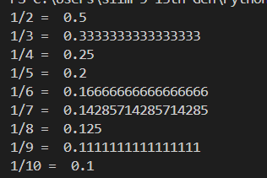

Q.3 Write a program using a while loop that asks the user for a number, and prints a countdown from that

number to zero.

Code :

a=int(input("Enter a number : "))

print("Countdown till zero >> ")

while a>=0 :

    print(a)

    a=a-1

Output :   
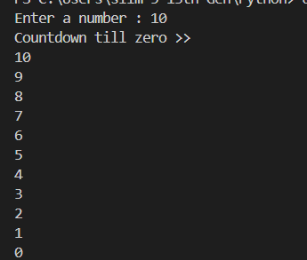

Q.4. Write a python script to print the current date in the following format “Mon August 12 02:26:23 IST 2024”.

Code :

import time

print(time.strftime("%a %B %d %H:%M:%S IST %Y"))

Output :



Q.5. Write a python program to find largest of three numbers.

Code :

a=int(input("Enter number " ))

b=int(input("Enter number " ))

c=int(input("Enter number " ))

if a>b :

    if a>c:

        print(a,"is the largest number ")

    else :

        print(c,"is the largest number ")

else :

    if b>c :

        print(b,"is the largest number ")

    else : print(c,"is the largest number ")

Output :

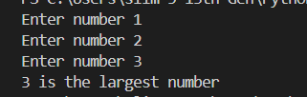

Q.6. Write a Python program to convert temperatures to and from Celsius, Fahrenheit.

Code :

temp = input("Enter temperature (e.g., 32F, 100C): ")

degree = int(temp[:-1])

unit = temp[-1]

if unit.upper() == "C":

    fahrenheit = (degree * 9/5) + 32

    print(f"{degree}C is {fahrenheit:.1f}F")

elif unit.upper() == "F":

    celsius = (degree - 32) * 5/9

    print(f"{degree}F is {celsius:.1f}C")

else:

    print("Invalid input")

Output :



Q. 7) Write a Python script that prints prime numbers less than 20.

Code :   
print("Prime numbers are : ")

for i in range(2,21) :

    found=True

    for j in range (2,i):

        if i%j==0 :

            found=False

            break

    if found==True :

        print(i)

Output :

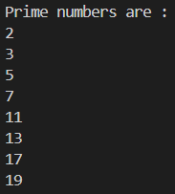

Q.8. Write a program that accepts the lengths of three sides of a triangle as inputs. The program output should

indicate whether or not the triangle is a right triangle (Recall from the Pythagorean Theorem that in a right

triangle, the square of one side equals the sum of the squares of the other two sides).

Code :

a=int(input("Enter side " ))

b=int(input("Enter side " ))

c=int(input("Enter side " ))

found=False

if a*a == b*b + c*c :

    found=True

if b*b == c*c + a*a :

    found=True

if c*c == b*b + a*a :

    found=True

if found :

    print("Triangle is right triangle")

else :

    print("Triangle is not right triangle :")

Output :   
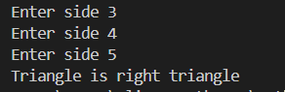

Q.9. Write a python program to find the best of two test average marks out of three test’s marks accepted from

the user.

Code :

a=int(input("Enter marks of test1 : "))

b=int(input("Enter marks of test2 : "))

c=int(input("Enter marks of test3 : "))

m1=(a+b)/2

m2=(c+b)/2

m3=(a+c)/2

if m1>m2 :

    if m1>m3:

        print("Average of best two test marks out of three test’s marks is",m1)

    else :

        print("Average of best two test marks out of three test’s marks is",m3)

else :

    if m2>c :

        print("Average of best two test marks out of three test’s marks is",m2)

    else : print("Average of best two test marks out of three test’s marks is",m3)

Output :   
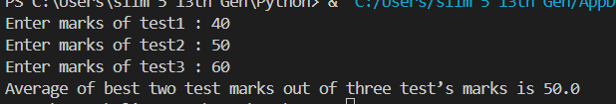

Q.10.

Develop a Python program to check whether a given number is palindrome or not and also count the

number of occurrences of each digit in the input number.

Code :

number = input("Enter a value: ")

if number == number[::-1]:

    print("Palindrome")

else:

    print("Not Palindrome")

digit_count = {}

for digit in number:

    if digit in digit_count:

        digit_count[digit] += 1

    else:

        digit_count[digit] = 1

for digit, count in digit_count.items():

    print(f"{digit} appears {count} times")

Output :

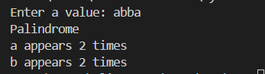

Q.11.

Code :

sentence = input("Enter a sentence: ")

words = sentence.split()

word_count = len(words)

digit_count = 0

upper_count = 0

lower_count = 0

for c in sentence:

    if c.isdigit():

        digit_count += 1

    elif c.isupper():

        upper_count += 1

    elif c.islower():

        lower_count += 1

print(f"This sentence has {word_count} words")

print(f"This sentence has {digit_count} digits")

print(f"{upper_count} upper case letters")

print(f"{lower_count} lower case letters")

Output :   
